**LOW LEVEL DESIGN (ADMIN MODULE)**

|  |  |
| --- | --- |
| **Project Code** | Team6 |
| **Project Name** | Online Banking System |

|  |  |  |
| --- | --- | --- |
| **Prepared/Modified by** | **Role** | **Date of Preparation** |
| Team 6 | Software Engineer |  |
| **Reviewed by** | **Role** | **Date of Review** |
|  | Software Engineer |  |
| **Approved by** | **Role** | **Date of Approval** |
| N.Kathiresan | Training Manager |  |
| **Circulation List** | [rishabh.waykole@capgemini.com](mailto:rishabh.waykole@capgemini.com)  [bindu.a.a@capgemini.com](mailto:bindu.a.a@capgemini.com)  [jyotsna.surve@capgemini.com](mailto:jyotsna.surve@capgemini.com)  [avinash.ramesh@capgemini.com](mailto:avinash.ramesh@capgemini.com)  [abhijeet.anand@capgemini.com](mailto:abhijeet.anand@capgemini.com)  [rohit.kanojia@capgemini.com](mailto:rohit.kaonjia@capgemini.com) | **Version Number of the template:1.0** |
| **Version Number** | 1.0 |  |

**Table of Contents**

1. Description Of The Unit 3

2. References 4

3. Dependencies / Assumptions 5

4. Class Diagrams 6

5. Sequence Diagrams 7

6. Design Components 8

6.1 List Of UI Components 8

6.2 List Of Design Classes 8

7. Re-Usable Routines/Components 9

8. Messages 10

9. Configuration Files 11

10.Action Flow Matrix 14

11.Program Specification / Pseudo Code 16

REVISION HISTORY OF THE WORK PRODUCT 17

# **Description Of The Unit**

# The admin module allows the admin to do two functionalities i.e to create a new account and to view the transactions.

# In the first function the admin creates a new account by using the information provided by the user and generates a user id and password which can be changed by the user afterwards.After clicking the submit button a successfully submitted page appears and the data is stored in the database.

# For the second function the admin can view the transactions that are done on the daily basis,monthly basis,quarterly basis and the yearly basis.On clicking the options for the given transactions the data is retrieved and is displayed to the admin.2. **References**

|  |  |
| --- | --- |
| **Reference** | **Description** |
| Repository reference |  |
| Class Diagram | /Project Documents/Design Documents/HLD/Class Diagrams/ Class Diagrams |
| URS | /Project Documents/Requirements/Case Study/ Survey Management System .doc |
| UTP | /Project Documents/Test Plan/UTP/Test Case/ Test_Case_Create_Survey_module.xls |
| DB Design | /Project Documents/Design Documents/HLD/DB Design/ Survey Management System_Team3_DBDESIGN.xls |

# **3. Dependencies / Assumptions**

**Dependencies:**

The admin should be logged in.

**Assumptions:**

The user gives information to admin on a written form

The transaction details are stored in the database.

# 4. **Class Diagrams**

# 5. **Sequence Diagrams**

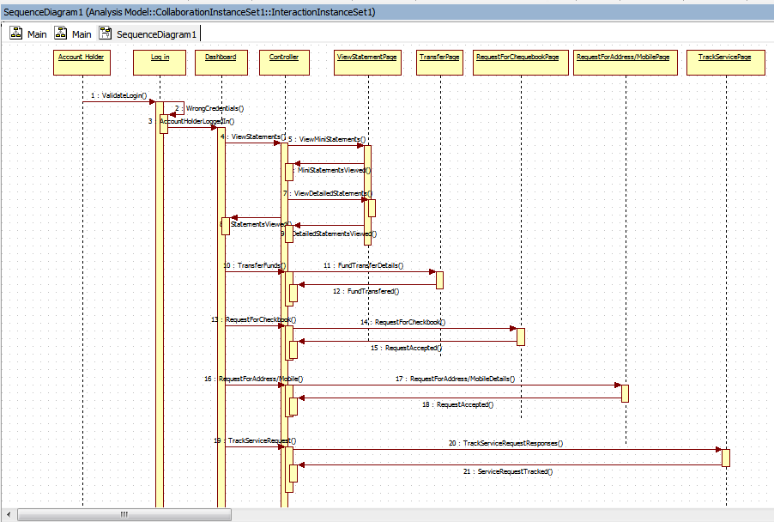

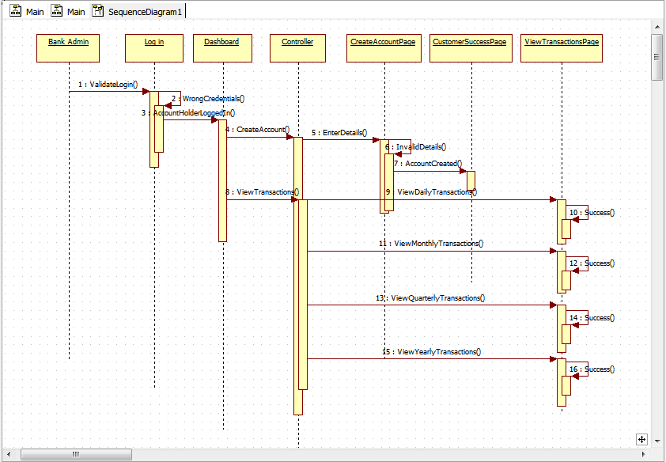

# 

# 

# 

# 

# 

# 

# 6. **Design Components**

## **List Of UI Components**

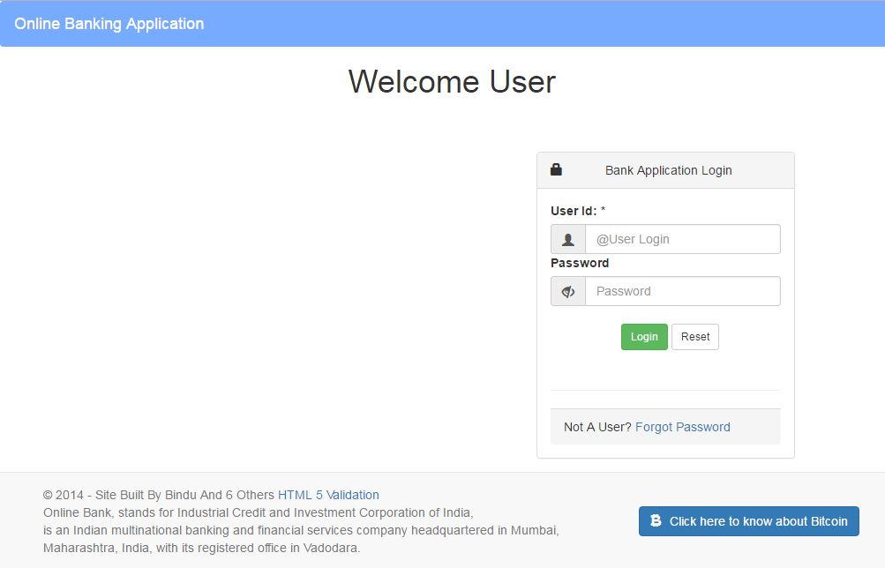

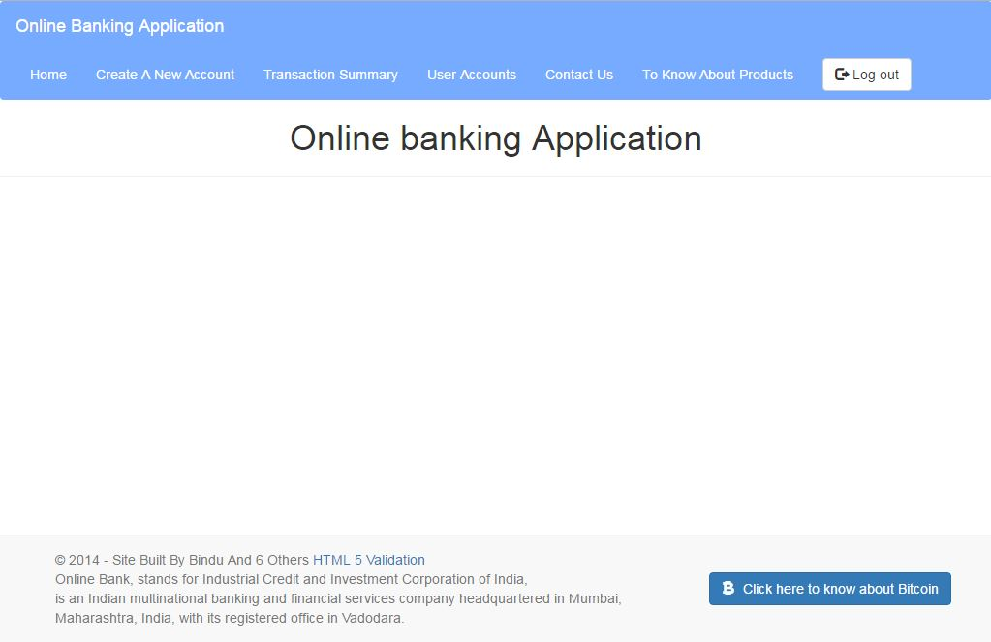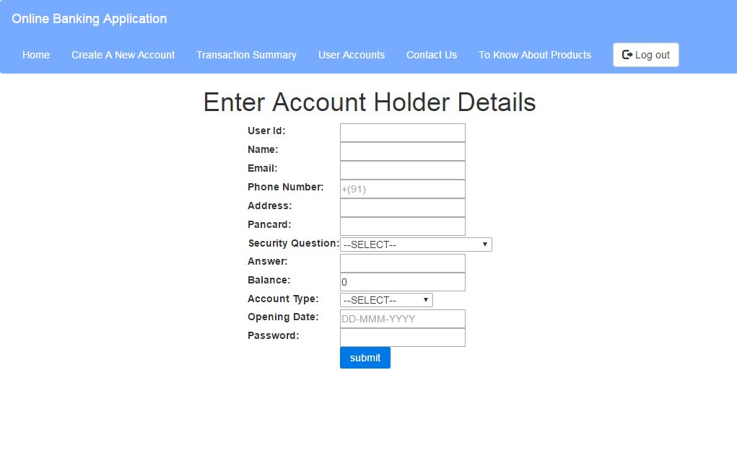

## trans.JPG

## 1.2 **List Of Design Classes**

|  |  |  |  |  |
| --- | --- | --- | --- | --- |
| **Sr. No.** | **LLD Name** | **Class Name** | **Method Name** | **Method Description** |
| 1 | Admin Module | Admin  Transaction. | Appropriate Getters and Setters methods, | Getters and Setters are used to retrieve and set the property values respectively. |
| 2 | Admin Module | BankingController. |  | The controller returns an object of ModelAndView.. |
| 3 | Admin Module | BankingServiceImpl | public boolean checkL(String adminId, String password)  void addDetails(Admin admin)  public ArrayList<Transcation> retrieveDaily();  public ArrayList<Transcation> retrieveMonthly();  public ArrayList<Transcation> retrieveQuarterly();  public ArrayList<Transcation> retrieveYearly(); | Calls methods of SurveyorDAOImpl class and returns the result to BankingController. |
| 4 | Admin Module | BankingDAOImpl | void addDetails(Admin admin)  public ArrayList<Transcation> retrieveDaily();  public ArrayList<Transcation> retrieveMonthly();  public ArrayList<Transcation> retrieveQuarterly();  public ArrayList<Transcation> retrieveYearly();  . | inserts the details into the database and returns the result to BankingServiceImpl. |

# **7. Re-Usable Routines/Components**

**Re-Usable Routines/Components**

* DataAccessException class
* Database properties files
* Logger properties files

# **8. Messages**

|  |  |  |
| --- | --- | --- |
| **#.** | **Type** | **Message Text** |
| M1 | Error | UserId cannot be empty |
| M2 | Error | Question too long(max 100 characters allowed) |
| M3 | Error | Password too small(min 10 characters required) |
| M4 | Error | Enter proper Date |
| M5 | Error | Name cannot be empty |
| M6 | Error | Address cannot be empty |
| M7 | Error | Pan Card should not be empty |
| M8 | Error | Answer cannot be empty |
| M9 | Error | Survey description should not contain only special characters |
| M10 | Error | Please select a Question type |
| M11 | Error | Please select a account type |
| M12 | Error | Please select valid number of option |

# 9. **Configuration Files**

|  |  |  |
| --- | --- | --- |
| **File Name** | **Path** | **Description** |
| oracle.properties | /Development/Source | To configure database connection. |
| Web.xml | /Development/Source | To configure the bean properties. |
| Dispatcher-servlet.xml | /Development/Source | To configure the request mapping and view resolver. |
| jpaContext.xml | /Development/Source | To store the datasource connection and entityconnection |

# 10. **Action Flow Matrix**

|  |  |  |  |
| --- | --- | --- | --- |
| **Sr. No.** | **Action** | **Description** | **Process** |
| 1 | On click of create account Button in home page | Gets registeration from | The admin inserts the data and clicks on submit button |
| 2 | On click of view transactions button in home page | details are reterived on transaction page | Data is shown on transaction page |

# 11. **Program Specification / Pseudo Code**

**REVISION HISTORY OF THE WORK PRODUCT**

|  |  |  |  |  |  |
| --- | --- | --- | --- | --- | --- |
| **#** | **Date** | **Version #** | **Section Changed** | **Details of changes made** | **Approved By** |
| 1 |  | 1.0 | LLD prepared | N/A | N.Kathiresan |